**Assignment-5**

**Q1.** **How many types of conditions are available in conditional formatting on Excel?**

**Ans. There are 5 conditions available in conditional formatting.**

1. **Highlight Cells Rules:** The first type of the five types of conditional formatting in Excel is the Highlight Cells Rules. Under this type, we will give some specific conditions, and the presentation of the cells will change upon these conditions.
2. **Top and Bottom Rules** are the second type of*Conditional Formatting* in Excel. If you want to highlight the highest or lowest value from your data set or want to figure out the top or bottom percentage of data, then this type is the best choice for doing so.
3. **Data Bars:** If you want to compare the numerical values in your data set, then this condition will be an ideal choice. Based on the cell values, this condition will create bars that will portray both positive and negative values.
4. [**Color Scales**](https://www.exceldemy.com/excel-conditional-formatting-color-scale-per-row/). It displays the disposal of data in the data set. You can mix two colors or three colors on the scale. The topmost color will represent the greater values, the middle scale will represent the average values, and the bottom color scale will represent the lower values in a data set.
5. ***Icon Sets*.** This type also works as in the previous two examples. This condition implements icons in the selected cell range based on their cell values.

**Q2. How to insert border in Excel with Format Cells dialog?**

The best way to make a border in Excel is to apply one of the inbuilt options directly from the ribbon. Here's how:

* Select a cell or a range of cells to which you want to add borders.
* On the Home tab, in the Font group, click the down arrow next to the Borders button, and you will see a list of the most popular border types.
* Click the border you want to apply, and it will be immediately added to the selected cells.

For example, this is how you can apply an outside border around cells in Excel:

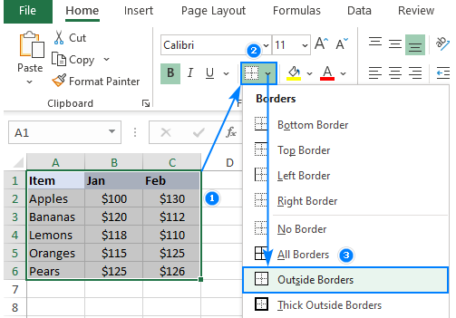

**Q3 How to Format Numbers as Currency in Excel?**

**Ans**. In this way we can add currency

* Select the cell u want to add currency in.
* Then go to home Tab.
* Click on date
* Scroll down
* Select currency

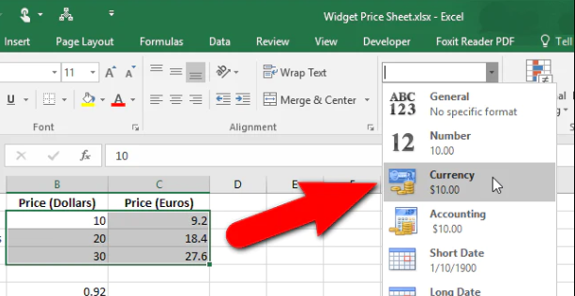

**Q4. What are the steps to format numbers in Excel with the Percent style?**

**Ans.** Select the cells you want to format, right-click and choose **"Format Cells"**, then select **"Percentage**" from the list of options.

**Q5. What is a shortcut to merge two or more cells in excel?**

**Ans.** Alt H +M+C

**Q6. How do you use text commands in Excel?**

**Ans** It is used to convert numbers to text within a spreadsheet.

Steps: